Getting Clean Event Files

1. Get the level 2 tar.gz files.

2. Untar the files using the command: tar xzvf filename.tar.gz

3. To untar all the files together, list the files in a directory using: ls *tar.gz > filename.sh

4. To open the file containing the list: gedit filename.sh

5. To get a list of all the clean event files:

a. Copy into gedit any clean event filename.
Eg: 20160331_T01_112T01_9000000406_level2_02740_V1.0/sxt/02740/sxt.01/AS1T01_112T01_9000000406sxtPC00_level2_cl.evt and save the file with a filename. Eg: clnevtlist.txt

b. Replace the font in red with * .

c. Use the command: ls path_of_the_directory/*/sxt/*/sxt.01/*cl.evt > cleanevtlist.txt to get the list of clean event files from all orbits into a single file.

Analysing the data

Getting the image, light curve and spectrum:

Use XSELECT to get the image, light curve and spectrum of the source.

The following link provides the information on using XSELECT to get the image, light curve and spectrum of the source.
https://heasarc.gsfc.nasa.gov/docs/software/lheasoft/ftools/xselect/xselect.html

1. First, one needs to enter the name of the directory in which the merged/single clean event file is placed. After entering the directory name, the merged/single clean event file has to entered.

2. To get the image of the source, use the commands >extract image >plot image.

- Region filters can applied after the image gets plotted in ds9 (http://ds9.si.edu/doc/user/index.html). This can be done by selecting the required region using the Region option from the Menu bar.

- The region filters have to saved. The command for applying region filters is filter region nameofsavedregionfile.reg. The image has to be re-extracted and re-plotted.

- The image can be saved using the command >save image and it gets saved with an extension .img

3. To get the light curve, use the commands >extract curve >plot curve. The curve can be saved using the command >save curve and it gets saved with an extension .lc

4. To get the spectrum, use commands >extract spectrum >plot spectrum. The spectrum can be saved using the command >save spectrum and it gets saved with an extension .pha

5. The image, the curve and the spectrum can also be saved using the command >save all.

Getting the RAWX, RAWY coordinates:

1. Remove the region filter which is applied using the command > clear region filter.

2. Use the command > set xyname rawx rawy > extract image > plot image. Choose region (circle) and find the RAW centroid co-ordinates.

Analysing the spectrum:

1. For analysing the spectrum, xspec tool is used.

2. XSPEC requires the spectrum data file (.pha), the background file (.pha), response file (.rmf) and the arf file (.arf).

3. Using the following link, one can fit the appropriate model for the data. The chapter “Walks through XSPEC” explains the analysis with an example.

https://heasarc.gsfc.nasa.gov/xanadu/xspec/XspecManual.pdf

ARF, Background and RMF used:

On -axis ARF files:
FW - central 1 arcmin removal – extraction radius 5 arc min: sxt_fw_excl01_v02.arf
FW – without removal - extraction radius 5 arc min: sxt_fw_v02.arf
PC – central 1 arcmin removal - extraction radius 16 arc min: sxt_pc_excl01_v03.arf
PC – central 2 arcmin removal - extraction radius 16 arc min: sxt_pc_excl02_v03.arf
PC – central 3 arcmin removal - extraction radius 16 arc min: sxt_pc_excl03_v03.arf

Background File: SkyBkg_comb_EL3p5_Cl_Rd16p0_v01.pha (same for PC and FW mode)

RMF File: sxt_pc_mat_g0to12.rmf (same for PC and FW mode)

Creating off-axis ARFs from on-axis ARFs using SXTMKARF tool:

1. Download the SXTMKARF tool from Utilities section on the AstroSat SXT POC website. (*edit*). And install with the instructions given in the same website.

2. To run the program,
- Enter the .pha file created using XSELECT, enter the name for the output ARF file which will get created after running the code, enter the RMF, on-axis ARF files. Also, change the ARF names indicated after 'cphead'.

- Type chmod 755 sxtmkarf.sh, which gives the permission to run the script. Then run ./sxtmkarf.sh .

- After running ./sxtmkarf, the code will ask for RAWX, RAWY co-ordinates. These co-ordinates can be obtained from XSELECT using the command xyname rawx rawy. After enterin thses co-ordinates, a new off-axis ARF will be generated.

- Example:
sxtmkarf phafile=crab_pc_1arcmin_spec.pha outfile=sxt_pc_excl01_v03_offax.arf rmffile=sxt_pc_mat_g0to12.rmf inarffile=sxt_pc_excl01_v03.arf expofile=NONE psfflag=N vigfile=CALDB srcx=-1 srcy=-1 chatter=4 clobber=Y history=Y
cphead sxt_pc_excl01_v03.arf+1 sxt_pc_excl01_v03_offax.arf+1

Commands used to analyse Crab data:

The following commands were used in XSPEC to analyse the data:

Energy range selected: 0.7 keV – 7.0 keV

1. grppha command: > grppha
a. Enter the original .pha spectrum file (filename.pha)
b. Change the name of original .pha file and enter the new name. (filename_grp.pha)
c. Enter the background file name. (> command chkkey backfile filename.pha)
d. Enter the response filename. (> command chkkey respfile filename.rmf)
e. Enter the arf filename. (> command chkkey ancrfile filename.arf)
f. Enter the number of channels to be grouped. (command > group min 60)
e. Enter exit.

2. First, the data file i.e. the .pha spectrum file has to be entered.
> data filename.pha.
Subsequently, the background file, the response file and the ancillary response file
> back SkyBkg_comb_EL3p5_Cl_Rd16p0_v01.pha ,
> response sxt_pc_mat_g0to12.rmf
> arf filename.arf (corresponding to the data file)

3. The spectral model used was (tbabs*powerlaw).
- Command > model tbabs*powerlaw
- Enter the values of nH, PhoIndex, norm as 0.21, 2.14, 10.4 and fit.

4. gainfit command: > gain fit (*edit*)
After using the gainfit command, a slope prompt appears. The slope should be entered as -1,1. After entering the slope, an appropriate offset value is generated and the slope value is frozen to 1. (*edit* -1,1 gives error, however, 1,-1 doesn’t)

5. Abundance: > abund wilm

6. Xsect : > xsect bcmc

7. Systematic command:
For Crab, the systematic used was 0.02.
> systematic 0.02
8. Fit command:
> fit

9. Error command:
Determines the error in the three parameters.
> error 1 2 3

1. PC mode:

Observation dates: 31.03.2016

Orbit Used: 02741

a. 1 arcmin removal: extraction radius 16 arcmin:

On-axis ARF used: sxt_pc_excl01_v03.arf

The plot below was obtained using the commands mentioned above.

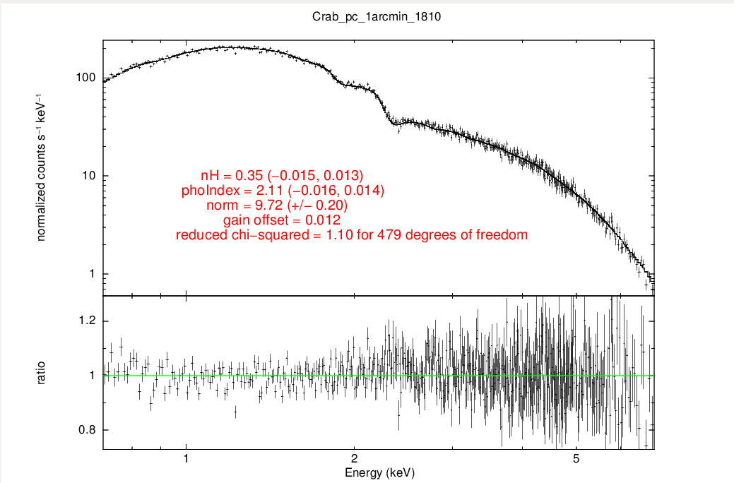

Similar plots can be obtained for:
PC – central 2 arcmin removal - extraction radius 16 arc min: sxt_pc_excl02_v03.arf
PC – central 3 arcmin removal - extraction radius 16 arc min: sxt_pc_excl03_v03.arf

2. FW Mode:

Observation dates: 31.03.2016

Orbits to be Merged: 02745 – 02816

Merging the clean event files:

1. Download SXTEVTMERGERTOOL from the AstroSat website.
http://www.tifr.res.in/~astrosat_sxt/page1.php

2. Extract the files.

3. The readme file contains the commands for merging the clean event files of different orbits into one clean event file.

ARFs to be used:

1. FW - central 1 arcmin removal – extraction radius 5 arc min: sxt_fw_excl01_v02.arf
2. FW – without removal - extraction radius 5 arc min: sxt_fw_v02.arf

Similar procedure and commands have to be followed to get the plots in FW mode.

Important Links:

1. For using XSELECT: http://www.swift.ac.uk/analysis/xrt/xselect.php

2. AstroSat POC: http://www.tifr.res.in/~astrosat_sxt/home.php

